"Wattpad Beta" mobile app testing
on Redmi 8 , Android version:
Android 10 QKQ1.191014.001

Bug Report

ID number | #1 | automatically getting in bug tracking system
Bug Summary | The button “главная ” is not visible
Reporter | Karine Asatryan
Submit Date |  | automatically getting in bug tracking system
Platform | MIUI Global 12.5.3
Operating System | Android 10 QKQ1.191014.001
Browser | -
Severity | Minor
Priority | Medium
Status |  | automatically getting ‘Open’ in bug tracking system
Assigned to | Developer
Version | Wattpad 9.41.0.1
Environment | prod
Component/tag | UI
Screenshot/video | screenshot1

Precondition: -

Description: The button “попробуйте премиум ” partially covers the button “главная” when the app language is Russian

Steps to reproduce
- Launch the app
Expected result
The button “главная” should be visible wholly.

Actual result
The button “главная” is visible partially.

Notes: -

References: -
Screenshot 1:
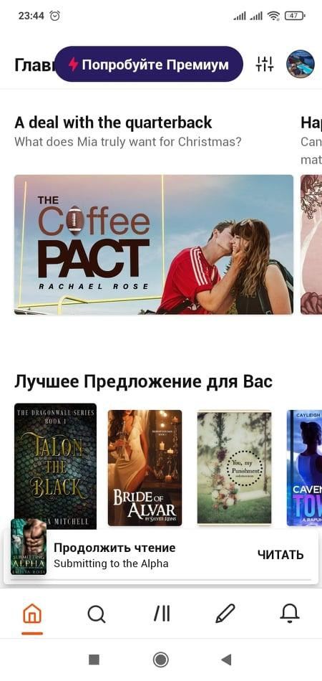

Bug Report

ID number | #2 | automatically getting in bug tracking system
Bug Summary | “Dark mode” option does not work
Reporter | Karine Asatryan
Submit Date |  | automatically getting in bug tracking system
Platform | MIUI Global 12.5.1
Operating System | Android 10 QKQ1.190910.002
Browser | -
Severity | Medium
Priority | Medium
Status |  | automatically getting ‘Open’ in bug tracking system
Assigned to | Developer
Version | Wattpad 9.41.0.1
Environment | prod
Component/tag | Settings
Screenshot/video | -

Precondition: “Dark mode” is enabled on the phone settings

Description: It is not possible to disable the “dark mode” form the app settings when “dark mode” is enabled on the phone settings.
Steps to reproduce
1.Launch the app
2.Go to “settings”- “Dark mode”
3.Press on the button “off” in “dark mode” selection list
Expected result
“Dark mode” should be disabled.

Actual result
The app stays in dark mode

Bug Report

ID number | #3 | automatically getting in bug tracking system
Bug Summary | “Profile picture” is not updating correctly
Reporter | Karine Asatryan
Submit Date |  | automatically getting in bug tracking system
Platform | MIUI Global 12.5.1
Operating System | Android 10 QKQ1.190910.002
Browser | -
Severity | Medium
Priority | Medium
Status |  | automatically getting ‘Open’ in bug tracking system
Assigned to | Developer
Version | Wattpad 9.41.0.1
Environment | prod
Component/tag | UI
Screenshot/video | -

Precondition: -

Description: The picture is not updated on the home page when the picture is changed in app settings.

Steps to reproduce
1.Launch the app
2.Go to “settings”- “Change the profile picture”
3.Change the picture
4.Go back to home page
Expected result
Profile picture on the home page should be updated.

Actual result
The profile picture is not updated on the home page.

Notes: Profile picture is updated after relaunching the app.
Bug Report

ID number | #4 | automatically getting in bug tracking system
Bug Summary | “Shake for help” option is not working
Reporter | Karine Asatryan
Submit Date |  | automatically getting in bug tracking system
Platform | MIUI Global 12.5.1
Operating System | Android 10 QKQ1.190910.002
Browser | -
Severity | Medium
Priority | Medium
Status |  | automatically getting ‘Open’ in bug tracking system
Assigned to | Developer
Version | Wattpad 9.41.0.1
Environment | prod
Component/tag | Settings
Screenshot/video | -

Precondition: -

Description: “Shake for help” option in the “Help and support” field is not working

Steps to reproduce
1.Launch the app
2.Go to “settings”- “help and support”
3.Enable the option “Shake for help”
4.Go to any menu
5. Shake the phone
Expected result
Help center page should be opened.

Actual result
Help center page is not opened.
Bug Report

ID number | #5 | automatically getting in bug tracking system
Bug Summary | “Bell” button is not active, but works
Reporter | Karine Asatryan
Submit Date |  | automatically getting in bug tracking system
Platform | MIUI Global 12.5.1
Operating System | Android 10 QKQ1.190910.002
Browser | -
Severity | Medium
Priority | Medium
Status |  | automatically getting ‘Open’ in bug tracking system
Assigned to | Developer
Version | Wattpad 9.41.0.1
Environment | prod
Component/tag | UI
Screenshot/video | Screenshot N 2

Precondition: -

Description: The “Bell” button at the bottom panel is not active, but it is possible to press on it and go to “Updates”

Steps to reproduce
1.Launch the app
2. Press on the button “Bell” at the bottom
Expected result
It should be not possible to go to another page with disabled button

Actual result
The “Bell” button is not active, but it is possible to press and go to “Updates”
Screenshot N 2:
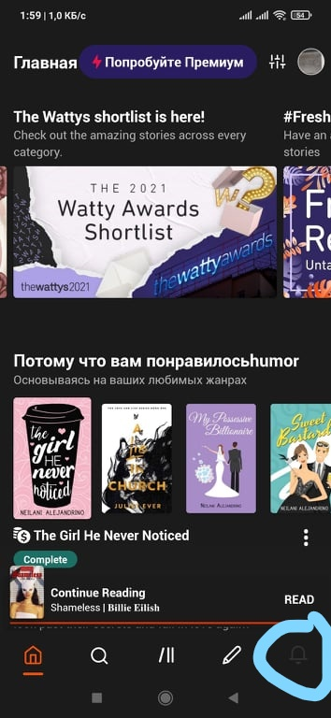

Bug Report

ID number | #6 | automatically getting in bug tracking system
Bug Summary | Missing buttons in “updates”
Reporter | Karine Asatryan
Submit Date |  | automatically getting in bug tracking system
Platform | MIUI Global 12.5.1
Operating System | Android 10 QKQ1.190910.002
Browser | -
Severity | Medium
Priority | Medium
Status |  | automatically getting ‘Open’ in bug tracking system
Assigned to | Developer
Version | Wattpad 9.41.0.1
Environment | prod
Component/tag | UI
Screenshot/video | Screenshot N 3, N 4

Precondition: -

Description: “Do you want report about a bug” button and option is absent from “updates”

Steps to reproduce
1.Launch the app
2. Press on the button “Bell” at the bottom
Expected result
A button about reporting a bug should be present

Actual result
A button about reporting a bug is absent

Screenshot N 3: Screenshot N 4:
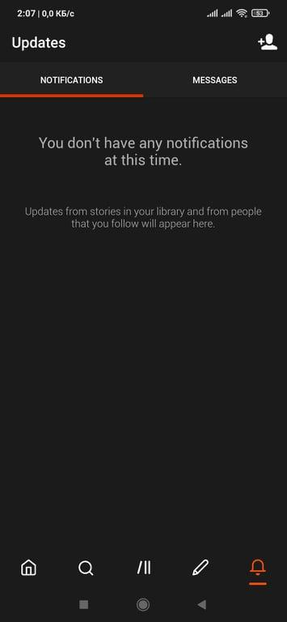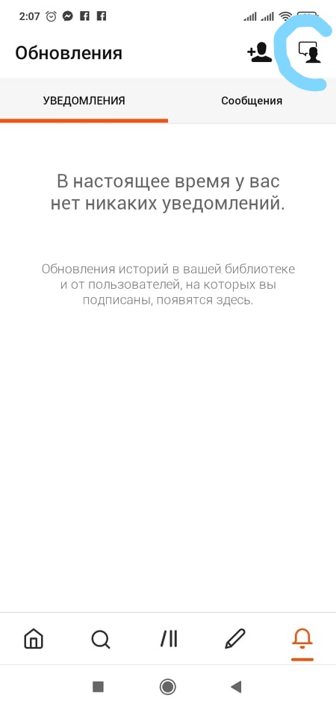

Notes: The testing is done on two different phones: Redmi Note 7 version Android 10 QKQ1.190910.002 and Redmi 8 version Android 10 QKQ1.191014.001

Notes:

1.There were many problems regarding changing language, sometimes the app crashes, sometimes not all the preferred stories’ languages were changed.
2. The app is not very user -friendly, ads appear everywhere, everytime)

